Chapter 19, Solution 33.

To get h₁₁ and h₂₁, consider the circuit below.

4 j6 I₂

+
-j3 +
I₁ V₁ 5 V₂=0
- -

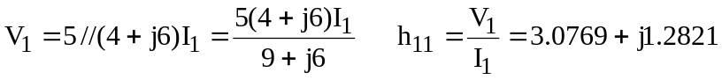

Also, 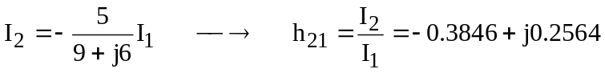

To get h₂₂ and h₁₂, consider the circuit below.

4 j6 I₂
I₁

+ +
-j3 +
V₁ 5 V₂
- -

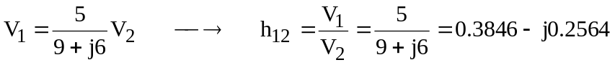

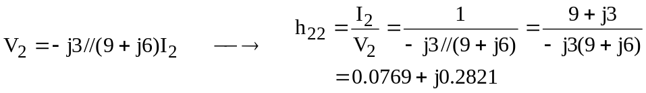

Thus,

